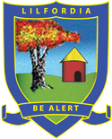

PARENT’S
INFORMATION MANUAL

SCHOOL CONTACT DETAILS

School Address: Town Office
Private Bag 304B 190 Sam Nujoma St, Milton Park
Harare | Harare
 | 252012-4 / 0773-060238
HEADMASTER: | Mr. D. Campbell
 | headmaster@lilfordia.com
 | 0773-634396
SUPERINTENDENT: | Mrs. L. Campbell
 | l.campbell@lilfordia.com
 | 0772-241480 (anytime)
BURSAR: | Mrs. S. Jones
 | sylvia@lilfordia.com
 | 0772-266264
ADMISSIONS & | Mrs. P. Squire
ADMINISTRATION: | pippa@lilfordia.com
 | 0772-305233

DIRECTOR OF SPORT: Mrs. M. Houghton
mary@lilfordia.com
0772-327973
HANDY CHECKLIST

BEFORE YOU LEAVE HOME
Checked the uniform fits? _____
Copy of new medical aid card _____
Packed ALL toiletry items & MARKED them?
(1 toothbrush, 1 scrubbing brush,
Girls - 1 brush, 1 comb, Boys - comb only.) _____

HAIRCUT _____
Do shoes fit? Are they marked? _____
Have you packed wraps and costumes? _____
Dressing gown cord (sewn on & marked) _____

AT HOME
Changed your address / telephone / email? _____
Do we have a Harare contact number? _____
Spare name tags (10)
(Only when your child first comes to school).
DO NOT USE IRON ON LABELS _____
Any medical information updates we need to know? _____
Check party date & collect invitation _____

ALWAYS PHONE THE SCHOOL BEFORE A MATCH IF YOU THINK YOUR CHILD IS PLAYING AND CHECK COMMUNICATOR. MATCHES COULD HAVE BEEN CANCELLED OR YOUR CHILD MAY NOT BE PLAYING

IMPORTANT INFORMATION

PLEASE NOTE

AT THE BEGINNING OF TERM
Boarders arrive between 14:00 - 16:00 in FULL No. 1s (1st & 3rd Term)
Day Scholars arrive at 07:15 the following day in No. 1s without tie.
2nd Term - Blue longs, white shirt, tie & blazer (G1-3 wear jerseys). Girls wear white socks, boys wear brown socks. Day Scholars wear same kit as boarders (but no tie).

FEES
These must be paid in advance or at the very latest at the beginning of term.
If fees are not paid in full or according to previous arrangements, your child will not be allowed to return.
A full term’s notice MUST be given of the intention to remove your child/children from the school. Failure to do so will result in you having to pay a full term’s fees in lieu of notice.

ATTENDANCE / EXEATS

Children will NOT be allowed to miss any school functions ie. Church Service, Concert, Sports Day, Gala etc.

PLEASE arrive on time for these events - it is NOT fair on your children if you are late. Please contact the school if you are going to be late collecting your child.

Taking time off during the school week is unacceptable. Please ensure all professional appointments are conducted during exeats/holidays.

Leaving early at the end of term or arriving late at the start of term is frowned upon.

ABSENTEEISM is NOT acceptable except in really serious cases of illness, where the child is actually confined to bed. Please be sensible about this.

NEWSLETTER

This will be circulated before each exeat via the school communicator. It is essential that you read the newsletter, it contains vital information.

CHANGE OF ADDRESS

YOU must inform the office of any change of address or telephone numbers. It is ESSENTIAL that we have your correct contact details AT ALL TIMES.

MEDICATION
ALL medication to bear the child’s FULL name, and must be handed in at the office or dispensary BY THE PARENT/S. Make sure the office is aware of the ailment for which your child is being treated. Medicine must be handed personally to either the nursing sister or the superintendent.

If your child develops any serious allergies OR has an operation or accident during the holidays, please inform the superintendent or nursing sister in writing at your earliest convenience.

MAIL

PLEASE write to your children via email (pippa@lilfordia.com) or leave a letter in the office which will be distributed on the day nominated. Letters are given out at lunch and supper line up. NO phone calls are allowed, but messages (e.g. birthday wishes will be passed on).

VISION AND HEARING TESTS

Every Grade 1 child (and new comers higher up the school) will need a vision and hearing test before they start school. A certificate from the doctor will be required to show the teacher.
Please hand the Reports into the School or Town Office.

BEDWETTERS

Please supply child with an EXTRA pair of pyjamas, two extra sheets and a plastic draw sheet. Pampers nappies are absolutely acceptable.

TEAM PLAYERS

It is ESSENTIAL that all pupils representing a school team bring a sleeping bag and travel bag to school.

NO RAIN COATS

NO COLOURED CLOTHES (Except for girls - see clothing list)

TOILETRIES

All toiletries are provided by the school. Should your child suffer from a dermatological complaint that warrants specialized ‘cosmetics’ please inform the Superintendent and supply the necessary toiletries.

Grade 7 girls may keep their own personal cream and shampoo in the dormitory. ONLY Grade 5, 6 and 7 girls and Grade 7 boys may bring ROLL ON deodorant. Spray deodorant is not allowed. (Numerous reasons for this.)

MARK
Toothbrushes, combs etc by scratching the name and then going over it with an indelible marker. Do not use nail polish or a nametape.

STATIONERY

Please refer to your newsletter for any specific requirements from the class teacher for your children’s needs in each grade.

2 x Colouring/Activity books and wax crayons are required for all Grade 1 and 2 pupils for use in the dormitory during the ’rest’ period.

BOARDING

We are a weekly boarding school. Pupils are to be collected on Friday at 12.15 pm and returned on Monday no later than 7.15 am. If your child is involved in sport on a Saturday, they will stay at school on Friday night and can be collected at the end of sport on Saturday.

BUS SERVICE

Fares will be published termly. All payments must be done through the Bursar
(sylvia@lilfordia.com). At the beginning of each term a “bus timetable” is sent out to all those who have paid for a place on the bus indicating the times of departure and arrival both to and from Westgate and Lilfordia.

HAIR CUTS

At the beginning of each term and at the half term exeat children are to return with their hair cut - boys SHORT back, front and sides, NO steps, peroxide or fancy cuts. Girls check long fringes. Check your daughter has a hair length and style SHE can cope with, so she doesn’t have to rely on staff or seniors to do it for her. Bear in mind that during the swimming terms long hair does not dry quickly and could easily still be wet at bedtime. NEVER COLOUR i.e. peroxide hair. NO HAIR OIL - it stains hats, collars, pillowcases.

PARTIES

Every child in the school has a birthday party at some stage of the year. You are NOT required to bring anything except for the last Grade 7 year. The children invite 11 friends, and these parties are normally held on Fridays at 10:30. Parents are invited to attend. Please understand we have to fit all the children for that term and the following holiday month into limited Fridays, therefore we cannot have more than 2 of a Grade or 2 girls/ boys in the same grade. We try as far as possible to have this party close to their actual birth date, but seniors take precedence over juniors, and sport is taken into account as well as many other factors. So the party date may be totally out of sequence with the birthdays. PLEASE try and avoid asking for a change unless you have a really valid reason for the request. Please DO NOT miss this important event. The birthday recipients may leave at 12:15 providing there are no sporting commitments or other important events.

Grade 7 Party As this is their final party they are allowed: 1 small packet crisps, 1 small juice - NO bottles, 1 sweet roll, 1 small chocolate (e.g. freddo), 1 lollipop. No poppers. NO chewing gum. There are twelve children at the party, therefore, each child should receive the same amount of “goodies”.

CORPORAL PUNISHMENT

Corporal punishment is administered when necessary by the Headmaster.

SCHOOL PHOTOGRAPHS

Every term School Photos are taken. Parents will receive an order form from which you can chose the photos you want and pay the amount due at the Town Office or the School Office.

LINEN - ALL PUPILS

- PLEASE NOTE: Pillows remain at the school until the final year.

- Sheets, duvets and duvet covers to be single bed size. It is VERY difficult for your child to make a small bed neatly with HUGE sheets.

- NO fitted sheets.

SUNDRY REQUIREMENTS
N.B. NAME TAPE PLACEMENT REGULATIONS

1 x School Trunk (NOT SMALL) - needs to fit all clothes, blankets etc. _____
1 x Underblanket - ESSENTIAL _____
1 x duvet _____
2 x duvet covers _____
3 x Sheets _____
1 x Pillow _____
2 x Pillowcases _____
2 x Towels (NB hanging loops in the centre of longest edge) _____
1 x Brush/Comb (Girls), Comb for boys. MARKED _____
1 x Soft nailbrush. MARKED. _____
1 x Toothbrush. MARKED _____
1 x Coat-hanger (BOYS) - start of school career _____
4 x Coat-hangers (GIRLS) - start of school career _____
1 x Roll On Deodorant (Grade 5, 6 & 7 Girls and Grade 7 Boys ONLY) _____

1 x ‘hard topped’ brief case for books. (Grade IV and above only) _____

NB. Mosquito nets to be supplied by the School

NO SATCHELS OR RUCKSACKS

CLOTHING LIST

ALL CLOTHES TO BE CLEARLY MARKED with full first name and surname, INCLUDING ALL UNDERWEAR. DO NOT USE ‘IRON ON’ LABELS.

Please ensure that all clothes and shoes are the CORRECT size, in good repair, and the regulation school clothes are the correct colour - ROYAL BLUE not navy.

ALL articles of school clothing are to have TWO name tapes (excluding socks, underwear, jersey and blazers) SEE DIAGRAMS AT THE BACK OF THE BOOKLET.

Please adhere strictly to the clothing list. Any excess items will be sent home.

ABSOLUTELY NO - electronic devices, money, foodstuffs, chewing gum, jewellery (including St Christopher’s and Crosses on chains). Earrings to be sleepers or studs only - but no coloured stones.

Alice bands and hair ties must be royal blue and clearly marked. NO plain elastic. PLEASE send sufficient number of hair ties to replace lost/mislaid ones and one or two more Alice Bands - clearly marked. Hand these into the School Office.

Please supply the school with a minimum of 10 spare nametapes, and hand them in at the office in an envelope marked with the child’s name. This only needs to be done at the start of your child’s career at Lilfordia.

HANGING LOOPS to be put on ALL hats, jerseys, tracksuits, towels and bathing wraps. These items can be ruined in a short time if this regulation is not adhered to.

SEE DIAGRAMS AT THE BACK OF THE BOOKLET.

UNIFORM SUPPLIER / STOCKIST

GLEN ABBEY – Arundel Village, Mon – Fri 9 – 5pm, Sat 8 – 12pm.
0779-714597 / 04-338351, glenabbeyzim@gmail.com

THRIFT SHOP
Please contact the Superintendent to arrange an appointment.

CLOTHING LABELS (Allow for 6 weeks delivery, so please order in time)
Available from JUST LABELS - Contact: Ginny Sinclair 0772-286907

** = Grade 4 and above ONLY
# = Grade 1 & 2 ONLY

BOYS CLOTHING LIST
No. 1s – for every term
1 x Light grey boxer shorts (NO ZIP) (1st & 3rd term) _____
1 x blue trousers (2nd term only) _____
1 x Short sleeve white shirt (with top button) _____
1 x Regulation school tie _____
1 x pair light grey long socks _____
1** x Blazer with badge (Grade 4 & above) _____
BASIC - for every term
3 x Short sleeve blue shirts (with top button) _____
1 x Grey long-sleeve pullover (winter x 2) _____
5 x pairs proper Underpants (not “silkies”) _____
4 x Royal Blue Boxer shorts (NOT NAVY) _____
4 x Royal Blue sports shirts _____
1 x Lilfordia Tracksuit _____
1 x Dressing gown with cord sewn on & MARKED for evenings.
A buttoned dressing gown is more practical than a corded one.
(WARM for WINTER, SHORT-SLEEVED for SUMMER) _____
2 x pairs Garters - CLEARLY MARKED for team players _____
6 x pairs Beige Ankle socks _____
2 x Royal blue hats (NB. LOOP) _____
One on head, while one in the wash
1 x Brown lace-up shoes _____
1** x pair suitable trainers/boots/track shoes for
Appropriate sport or takkies for Grade 1 & 2 _____
1 x Slops/Rafters/crocs ESSENTIAL - MARKED
(These are worn in the evenings) _____
Track shoes are not allowed to be worn in the evenings
1 x Tennis racquet (Optional if not in a team) _____
1 x Sleeping bag (for Team players who will be travelling) _____
1 x Travel bag (for Team players who will be travelling) _____
SUMMER ONLY - 1st and 3rd Terms DO NOT BRING IN WINTER
3 x Khaki boxer shorts (NO ZIP) _____
1 x Royal Blue & Gold Lilfordia costume COMPULSORY _____
2 x Coloured bathing wraps - see diagram _____
2 x Summer pyjamas - not T-shirt & shorts _____
1 x Cricket Bat (optional if not in team) _____
2 x pairs long white cricket socks ESSENTIAL
if in a team . NO colour for cricket. _____
1 x BROAD brimmed white cricket hat – if in a team
(NO colour on rim, NO logo) _____
2 x pairs White boxer shorts (for cricket) – if in a team _____
2 x White short sleeve shirts (for cricket) – if in a team _____
1 x pair of WHITE skins (optional for cricket) _____
1** x pair Cricket boots (optional if not in a team).
Essential for 1st XI. Be sure they are suitable for cricket. _____
1 x Summer dressing gown (cord sewn on, or buttons only) _____
Cord also to be marked.

WINTER ONLY - 2nd Term DO NOT BRING IN SUMMER
2 x Royal blue trousers (elasticised waist)
NB. Correct size and Length. Your child feels awfully
embarrassed wearing longs that are too big, too short or too tight) _____
1 x Hockey Stick (optional if not in a team) _____
1 x Slippers/stokies/stompies ESSENTIAL _____
(NO slippers in summer)
2 x Winter pyjamas – not T-shirt & longs _____
1** x Rugby jersey for practice - any colour (Grade 2 + above) _____
1 x pair of BLACK skins (optional for rugby) _____
1 x pair shin pads for ALL Hockey players _____
1 x Warm winter dressing gown (cord sewn on or buttons only) _____
Cord also to be marked.
1 x Royal blue fleece _____
** = Grade 4 and above ONLY
# = Grade 1 & 2 ONLY

GIRLS CLOTHING LIST

No. 1s – for every term
1 x Royal blue skirt (must reach floor when kneeling) (1st & 3rd term) _____
1 x blue trousers (2nd term only) _____
1 x White short sleeve shirt (with top button) _____
1 x Regulation school tie _____
1 x pair white ankle socks _____
1** x Blazer with badge (Grade 4 & above) _____

BASIC - for every term
5 x Pants to match ROYAL blue (NOT NYLON) _____
1 x Grey Lilfordia long sleeve pullover (winter x 2) _____
4 x Royal blue shorts (boxers) _____
4 x Royal blue sports shirts _____
1 x Lilfordia Tracksuit _____
1 x Dressing gown for evenings with cord sewn on & MARKED
A buttoned dressing gown is more practical than a corded one.
(WARM for WINTER, SHORT-SLEEVED for SUMMER) _____
6 x pairs Beige ankle socks _____
2 x Royal blue hats (NB. LOOP) _____
One on head, while one in the wash
1 x pair Brown school shoes _____
1 x pair suitable trainers/track shoes for appropriate sport
For Grade 1 & 2 - Takkies _____
1 x Slops/Rafters/Crocs ESSENTIAL – MARKED.
(These are worn in the evenings)

Track shoes are not allowed to be worn in the evening _____

1 x suitable Party Wear - something simple, feminine & pretty _____
1 x pair Party Shoes (Takkies are NOT suitable) _____
5 x pairs coloured panties (MARKED) _____
1 x Tennis racquet (Optional if not in a team) _____
2 x Extra pairs white ankle socks (team players) _____
1 x Sleeping bag (for Team players who will be travelling) _____
1 x Travel bag (for Team players who will be travelling) _____

SUMMER ONLY - 1st and 3rd Terms DO NOT BRING IN WINTER
3 x khaki skorts _____
3 x blue short sleeved shirts (with top button) _____
1 x Royal Blue & Gold Lilfordia costume COMPULSORY _____

1 x Bathing cap if hair is long (Royal Blue) _____
2 x Coloured bathing wraps - see diagram _____
2 x summer pyjamas - not T-shirt & shorts _____
1 x Takkies/track shoes (tennis teams) _____
1 x Summer dressing gown (cord sewn on, or buttons only) _____
Cord also to be marked

WINTER ONLY - 2nd Term DO NOT BRING IN SUMMER
3 x blue short sleeve shirts (with top button) _____
2 x Royal blue slacks, elastic tops (NB Correct size and length.
Your child feels awfully embarrassed wearing longs that are
too big, too short or too tight) _____

1x Slippers/stompies/stokies. ESSENTIAL
(NO slippers in summer ) _____
2 x Winter pyjamas – not T-shirt & longs _____
1 x Hockey stick (Optional if not in a team) _____
1 x pair shin pads (team players) _____
2 x pairs garters (clearly marked) for Team Players _____
2 x Lilfordia Grey long sleeved pullover (NO buttons) _____
1 x Warm winter dressing gown (cord sewn on or buttons only) _____
Cord also to be marked
1 x Royal blue fleece _____
NAME TAPE REGULATIONS
To be STRICTLY adhered to
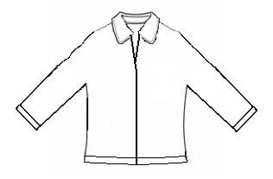
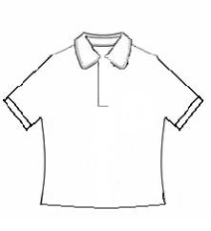

SPORTS SHIRTS
One name tape on the LEFT sleeve
One name tape on the collar

TRACKSUIT TOP & SCHOOL FLEECE
One name tape on inside BACK neck band
One name tape on RIGHT front waistband
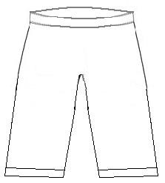

TRACKSUIT PANTS and WINTER LONGS
One name tape on inside CENTRE BACK band
One name tape 6” down outer RIGHT leg seam
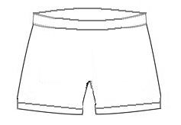

ALL SHORTS
One name tape inside centre back waistband
One on outer RIGHT leg hem
Loop and name tape in the CENTRE
NOT ON THE CORNER

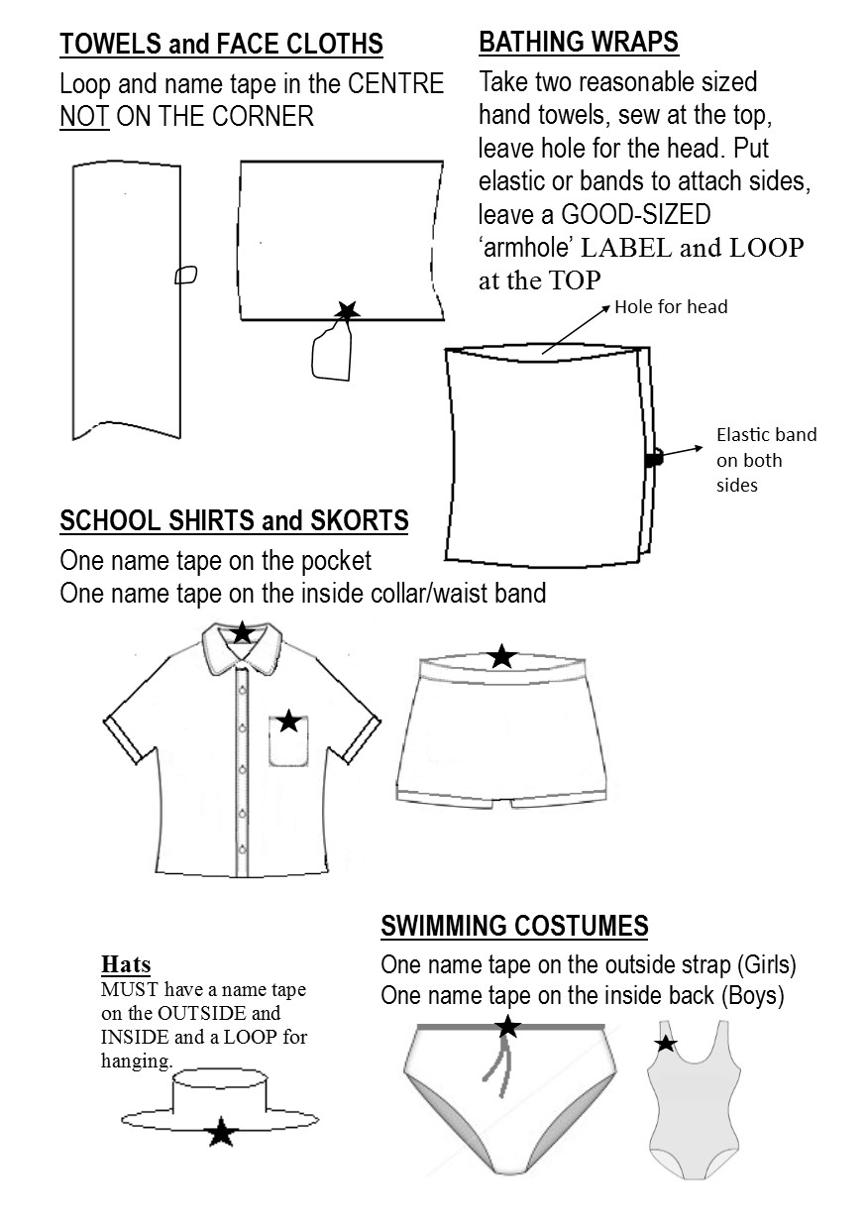

D6 School Communicator Program

Download the D6 School Communicator Program by going to the homepage of our website (www.lilfordia.com) and clicking on the D6 link. If you want to download it onto your phone, go to Playstore and follow the D6 Communicator link for Zimbabwe, Lilfordia School.

Make sure you select your child’s class and that you put your cellphone numbers with the zero in front eg. 0713208764.

Please contact:
Ath Squire (atherton@lilfordia.com)
or
support@school-communicator.com
if you have any problems.

